PRACTICAL-1
Aim: To study about Software Requirement Specification (SRS)

1. Introduction:

This document will propose all features and procedures to develop the system. It specially containing details about objectives, scope limitation, process model, primary requirements, team development, possible project risks, project schedule, and finally monitoring and reporting mechanisms.

Online Artificial Intelligence Portal is very useful for Educational Institute to prepare an exam, save the time that will take to check the paper and prepare mark sheets. It will help the Institute to testing of students and develop their skills. But the disadvantages for this system, it takes a lot of times when you prepare the exam at the first time for usage. And we need as many numbers of computers as the number of students.

The effective use of "Online Artificial Intelligence Portal", any Educational Institute or training centers can be use it to develop their strategy for putting the exams, and for getting better results in less time.

  - Purpose

The main objective of this document is to illustrate the requirements of the project Online Artificial Intelligence Portal. The document is developed to bring changes in the Online Examination System. The Exam paper is prepared dynamically based on the selected stream. The final product of the team will be meeting the requirements of this document.

  - Scope of the Project

- On-line Exam system is designed for Educational Institutes (like schools, universities, training centers).
- It allows the user to select the stream/topic.
- The system handles all the operations, dynamically prepares the question paper and generates reports as soon as the test is finish, that includes name, mark, time spent to solve the exam.
- Allow students to see or display his answers after the exam is finish.
- The type of questions is only multiple choice or true and false.

1.3 Project Definition

This project is basically updating the manual online examination paper setting system such that paper will be generated dynamically.
The different areas where we can use this application are:
- Any education institute can make use of it for conducting online exams where the system automatically generate the question papers with questions of different formats and distinct data values such that no one get the same as others
- It can be used by the Recruitment team to conduct the written tests for the students to be recruited.

  - References

- Object Oriented Modeling and Design with UML-Michael Blaha, James Rambaugh.
- Software Engineering, Seventh Edition, Ian Sommerville.
- IBM Red Books.
- IBM TGMC Sample Synopsis.
- IBM – www.ibm.in/developerworks

  - Overview

Existing System:-
The Question with same values will be repeated in many times.
Proposed System:-
The paper will be generated with random data values and in random format.

2. General Description:

2.1. Product Perspective

The proposed Online Artificial Intelligence Portal System will provide a Search functionality to facilitate the search of resources. This search will be based on various categories namely Stream/topic. An Arbitrary_originator functionality for generating random adequate data values and options. A Format_Creator procedure is meant to produce various formats of questions. An evaluation procedure for evaluating the answered question paper. A solution_provider for storing solutions of all problems in the database and can be accessed through Ques_Id.

2.2 System Interfaces:
This section describes how the software interfaces with other software products or users for input or output.

2.2.1 User Interface
Application will be accessed through a Browser Interface. The interface would be viewed best using 1024 x 768 and 800 x 600 pixels resolution setting. The software would be fully compatible with Microsoft Internet Explorer for version 6 and above. No user would be able to access any part of the application without logging on to the system.

2.2.2 Hardware Interface
Server Side:
- Operating System: Windows xp/2007 ,Windows ME
- Processor: Pentium 3.0 GHz or higher
- RAM: 256 Mb or more
- Hard Drive: 10 GB or more
Client side:
- Operating System: Windows 9x or above, MAC or UNIX.
- Processor: Pentium III or 2.0 GHz or higher.
- RAM: 256 Mb or more

2.2.3 Software Interface
- Database: DB2 Server.
- Application: AP (Active Server Pages)
- Web Server: IIS (Internet Information Services (IIS) is a powerful Web server that provides a highly reliable, manageable, and scalable Web application infrastructure).

2.2.4 Communications Interfaces
The Customer must connect to the Internet to access the Website:
- Dialup Modem of 52 kbps
- Broadband Internet
- Dialup or Broadband Connection with an Internet Provider.

PRACTICAL-3
Aim: To study about Activity diagram of Online Artificial Intelligence Portal

Activity diagrams are graphical representations of workflows of stepwise activities and action with support for choice, iteration and concurrency. In the Unified Modeling Language, activity diagrams are intended to model both computational and organisational processes (i.e. workflows). Activity diagrams show the overall flow of control.
Activity diagrams are constructed from a limited number of shapes, connected with arrows. The most important shape types:
- rounded rectangles represent actions;
- diamonds represent decisions;
- bars represent the start (split) or end (join) of concurrent activities;
- a black circle represents the start (initial state) of the workflow;
- an encircled black circle represents the end (final state).

Activity diagram shows the flow from one activity to another within a system. The activities may be sequential or branching objects that act and are acted upon. These also show the dynamic view of the system.
Activity diagrams, which are related to program flow plans (flowcharts), are used to illustrate activities. In the external view, we use activity diagrams for the description of those business processes that describe the functionality of the business system.
Activity diagrams allow you to think functionally. Purists of the object-oriented approach probably dislike this fact. We, on the other hand, regard this fact as a great advantage, since users of object-oriented methods, as well as users of functional thinking patterns, find a common and familiar display format, which is a significant aid for business-process modelling.
Because it is possible to explicitly describe parallel events, the activity diagram is well suited for the illustration of business processes, since business processes rarely occur in a linear manner and often exhibit parallelisms.

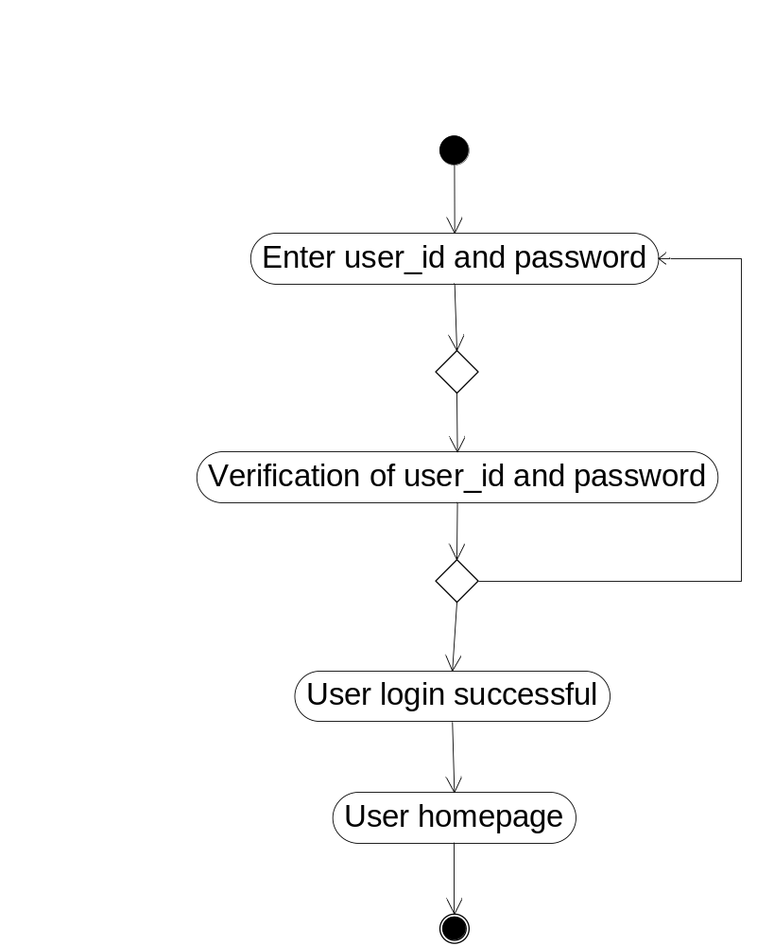

Fig: Activity Diagram for User Login

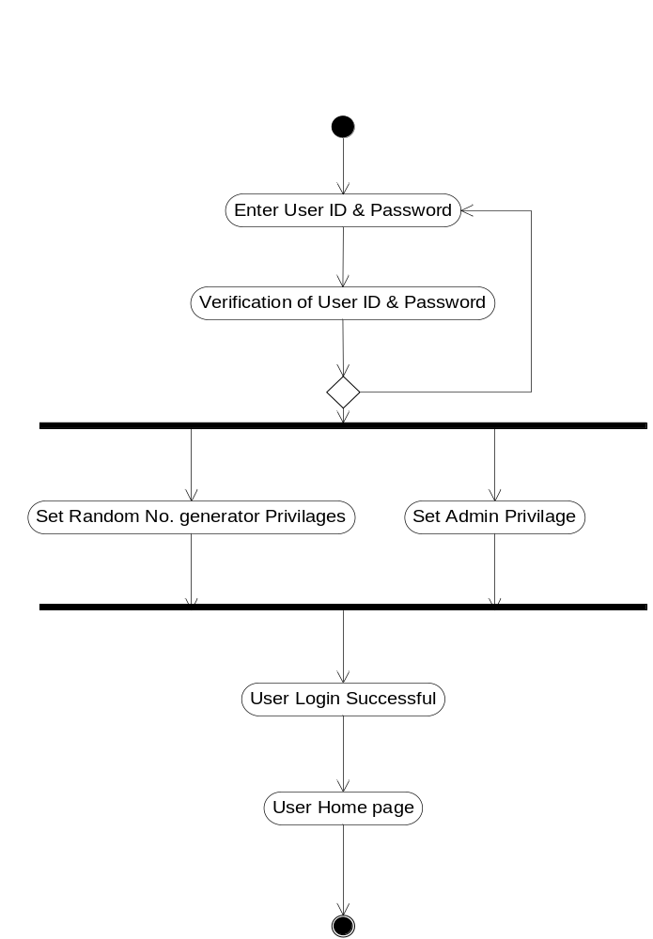

Fig: Activity Diagram for Privileged Login

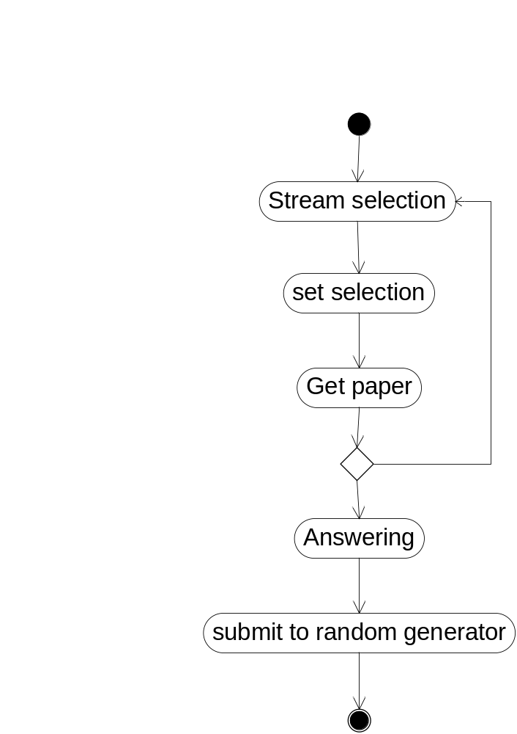

Fig: Activity diagram for Stream selection and Paper Answering

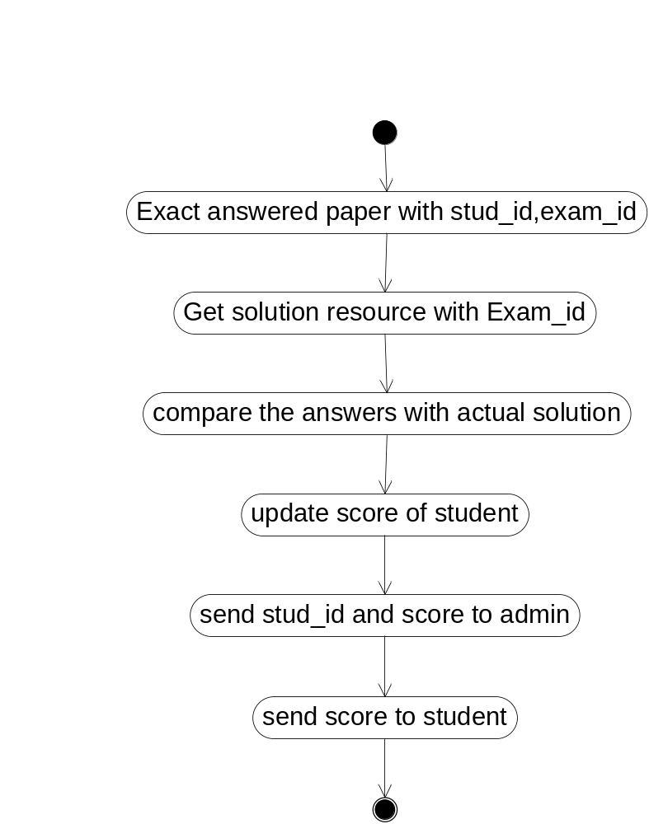

Fig: Activity diagram for Answer Verification

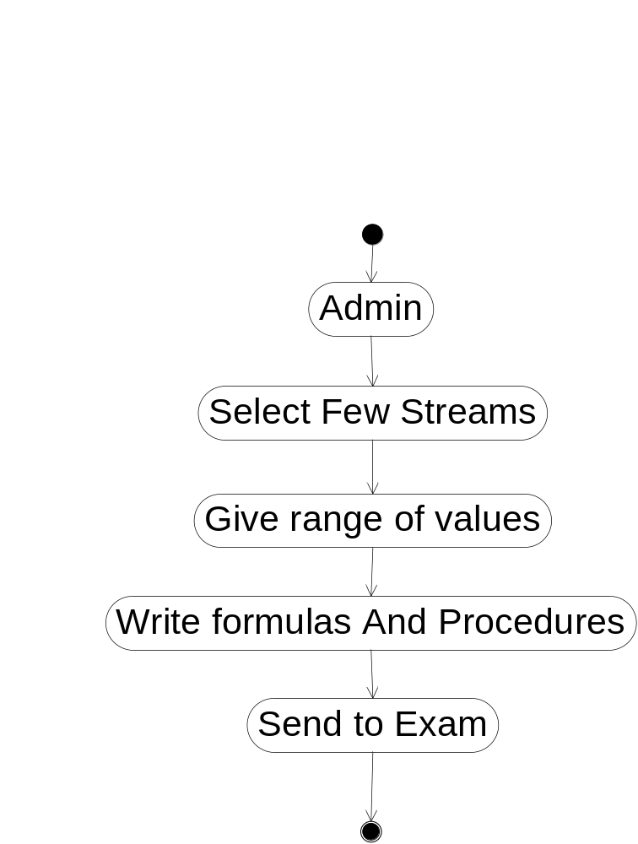

Fig: Activity diagram for Paper Setting

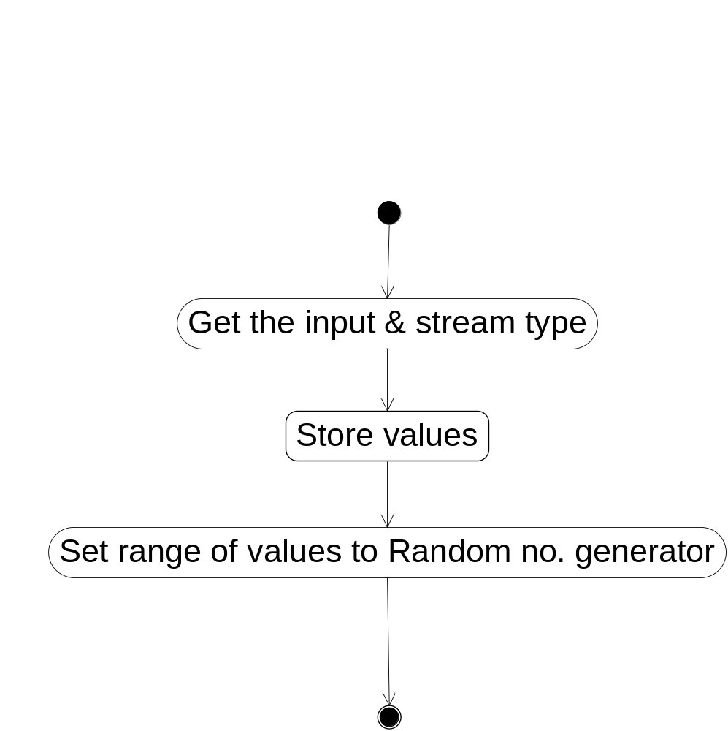

Fig: Activity Diagram for Exam

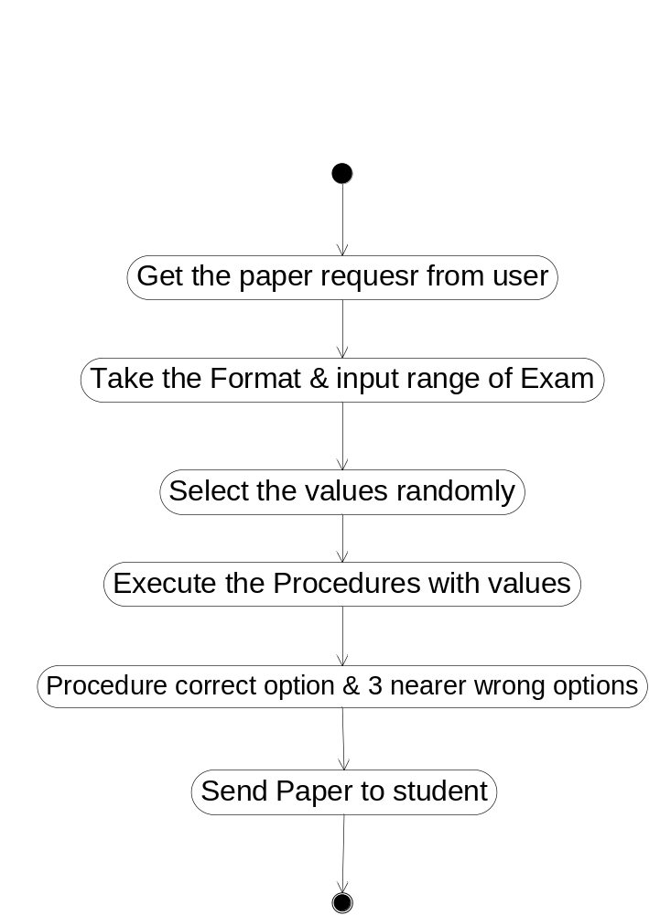
Fig: Activity diagram for Random Generation

The description for the Activity diagrams of Online Artificial Intelligence Portal is given below:

The student enters the user id and password. After verification of the id and password the student is successfully logged-in into his/her homepage. Then the student is allowed to select the stream. Then student sends request for the question paper. After sending the request , the question paper is generated. The student answers the questions and submits the paper. The random number generator compares the answers with the actual solution. After this, the scores of the student are updated, recorded and send to the student. Then the student logs out.

PRACTICAL-2

Aim: To study about Use Case diagram of Online Artificial Intelligence Portal

A use case diagram at its simplest is a representation of a user's interaction with the system and depicting the specifications of a use case. A use case diagram can portray the different types of users of a system and the various ways that they interact with the system.
The purpose of use case diagram is to capture the dynamic aspect of a system. But this definition is too generic to describe the purpose. So in brief, the purposes of use case diagrams can be as follows:
- Used to gather requirements of a system.
- Used to get an outside view of a system.
- Identify external and internal factors influencing the system.
- Show the interacting among the requirements are actors.
Use case diagrams are considered for high level requirement analysis of a system. So when the requirements of a system are analyzed the functionalities are captured in use cases.
So we can say that uses cases are nothing but the system functionalities written in an organized manner. Now the second things which are relevant to the use cases are the actors. Actors can be defined as something that interacts with the system.
The actors can be human user, some internal applications or may be some external applications. So in a brief when we are planning to draw an use case diagram we should have the following items identified.
- Functionalities to be represented as an use case
- Actors
- Relationships among the use cases and actors.
Use case diagrams are drawn to capture the functional requirements of a system. So after identifying the above items we have to follow the following guidelines to draw an efficient use case diagram.
- The name of a use case is very important. So the name should be chosen in such a way so that it can identify the functionalities performed.
- Give a suitable name for actors.
- Show relationships and dependencies clearly in the diagram.
- Do not try to include all types of relationships. Because the main purpose of the diagram is to identify requirements.
- Use note when ever required to clarify some important points.
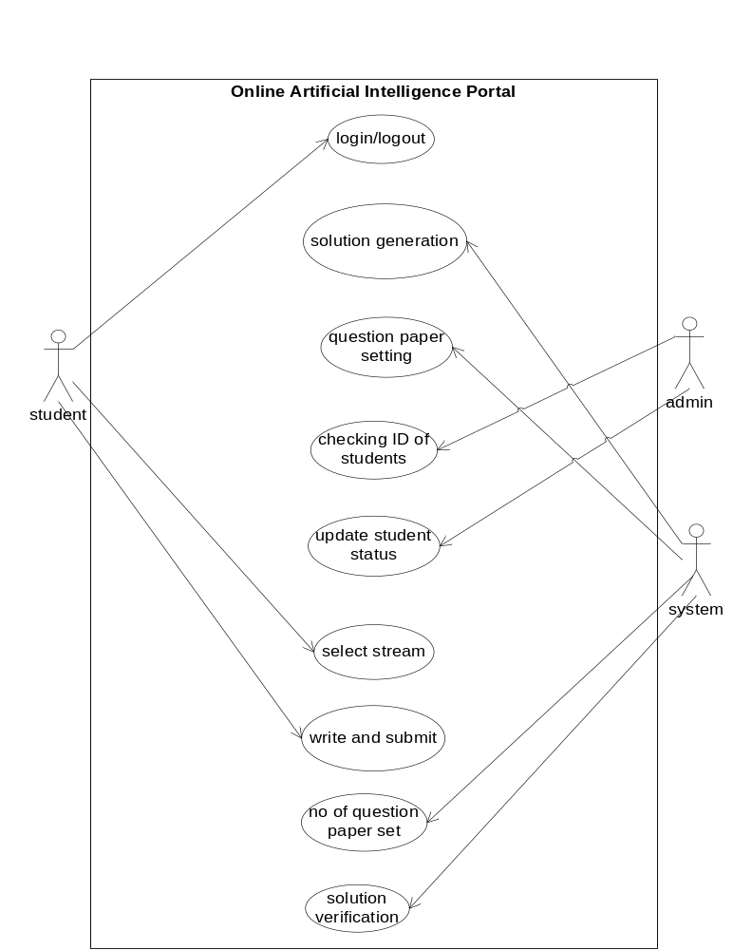
Fig: Usecase diagram for Online Artificial Intelligence Portal

The description of the Use case diagram of Online Artificial Intelligence Portal is given below:

There are three actors in the usecase.

They are student, system and admin. The student has three tasks to do.
- To do Login/logout from the system
- Selecting the stream of his/her choice
- To write and submit the answers
The admin has two tasks to perform.They are
- To check the ID of the students
- To update the status of the student
The system has four tasks to perform. They are
- To set the questions paper for the examination
- To generate the solution for the given question set
- To generate more than one question paper
- To verify the solution with the correct solution

PRCTICAL-4

Aim: To study about context diagram of Online Artificial Intelligence Portal

A Context Diagram in software engineering and systems engineering is a diagram that defines the boundary between the system, or part of a system, and its environment, showing the entities that interact with it. Context diagrams show a system, often software-based, as a whole and its inputs and outputs from/to external factors.
A context diagram can also list the classifications of the external entities as one of a set of simple categories which add clarity to the level of involvement of the entity with regards to the system. These categories include:
- Active: Dynamic external entities which frequently initiate events to achieve some goal or purpose (Examples: "Article readers" or "customers").
- Passive: Static external entities which infrequently interact with the system (Examples: "Article editors" or "database administrator").
- Cooperative: Predictable external entities which are used by the system to bring about some desired outcome (Examples: "Internet service providers" or "shipping companies").
- Autonomous (Independent): External entities which are separated from the system, but affect the system indirectly, by means of imposed constraints or similar influences

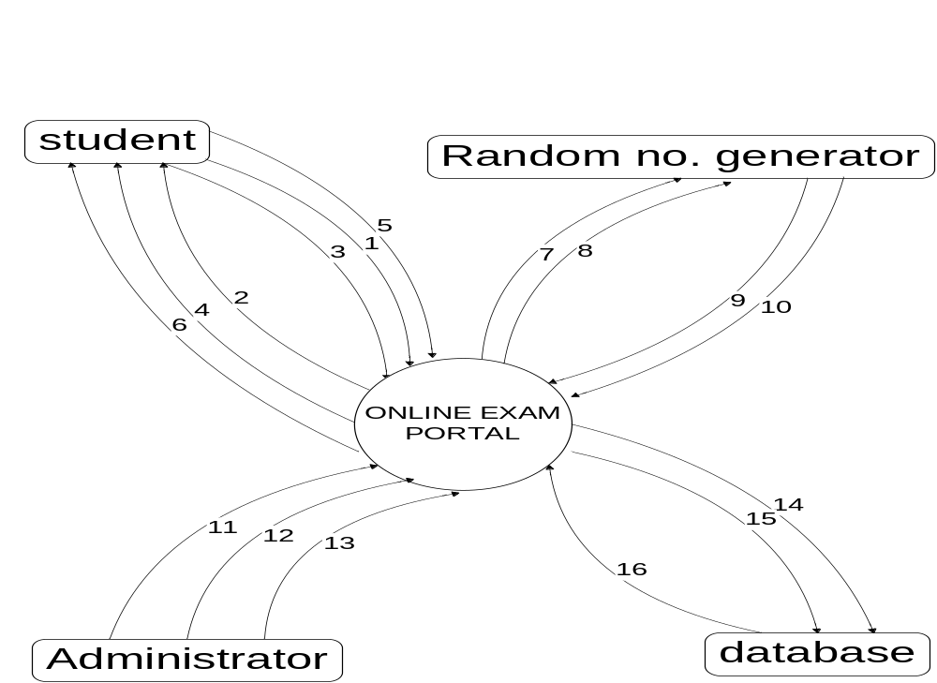

Fig: Context Diagram for Online Artificial Intelligence Portal

STUDENT

1. Login for student
2. Login successfully
3. Select stream
4. Get paper
5. Answer and submit
6. View scores

RANDOM No. GENERATOR

7. Get paper request from student
8. Take format and input range of exam
9. Set paper with correct options and three nearly wrong options
10. Send paper to database

ADMINISTRATOR
11. Maintain student data
12. Give input values and stream types
13 .Update student score

DATABASE
14. Extract answered paper with student id, exam id
15. Get solution resource with exam id
16. Compare the answers with actual solutions

The description for the Context diagram of Online Artificial Intelligence Portal is given below:
STUDENT
- Login page for student is displayed
- The student logs-in successfully when correct username and password are entered
- The student is allowed to select the stream of its own
- The student receives the question paper generated by random number generator
- The student answers the questions and submits it
- The student is allowed to view scores after examination
- The student requests for the question paper to random number generator
RANDOM No. GENERATOR
- The random number generator will take format and input range of exam
- The code generator will set question paper with correct option and three nearly wrong options
- When student will request for question paper then random number generator will send it to him/her
ADMINISTRATOR
- The administrator will maintain the student data
- The administrator will give input values and stream types
- The administrator will update the student score
DATABASE
- The database will extract answer paper of the student along with student id and exam id
- The database will get solution resource with exam id
- The database will compare the answers with actual solutions

PRACTICAL-7

Aim: To study about Class Diagram of Online Artificial Intelligence Portal

In software engineering, a class diagram in the Unified Modeling Language (UML) is a type of static structure diagram that describes the structure of a system by showing the system's classes, their attributes, operations (or methods), and the relationships among objects. The class diagram is the main building block of object oriented modelling. It is used both for general conceptual modelling of the systematics of the application, and for detailed modelling translating the models into programming code. Class diagrams can also be used for data modeling.
A class diagram is an illustration of the relationships and source code dependencies among classes in the Unified Modelling Language (UML). In this context, a class defines the methods and variables in an object, which is a specific entity in a program or the unit of code representing that entity. Class diagrams are useful in all forms of object-oriented programming (OOP). The concept is several years old but has been refined as OOP modelling paradigms have evolved.
In a class diagram, the classes are arranged in groups that share common characteristics. A class diagram resembles a flowchart in which classes are portrayed as boxes, each box having three rectangles inside. The top rectangle contains the name of the class; the middle rectangle contains the attributes of the class; the lower rectangle contains the methods, also called operations, of the class. Lines, which may have arrows at one or both ends, connect the boxes. These lines define the relationships, also called associations, between the classes.
There are three kinds of relationships used in this example:
- Association: For example, an Order Detail is a line item of each Order.
- Aggregation (association): In this diagram, Order has a collection of Order Details.
- Implementation (generalization): Payment is an interface for Cash, Check, and Credit.

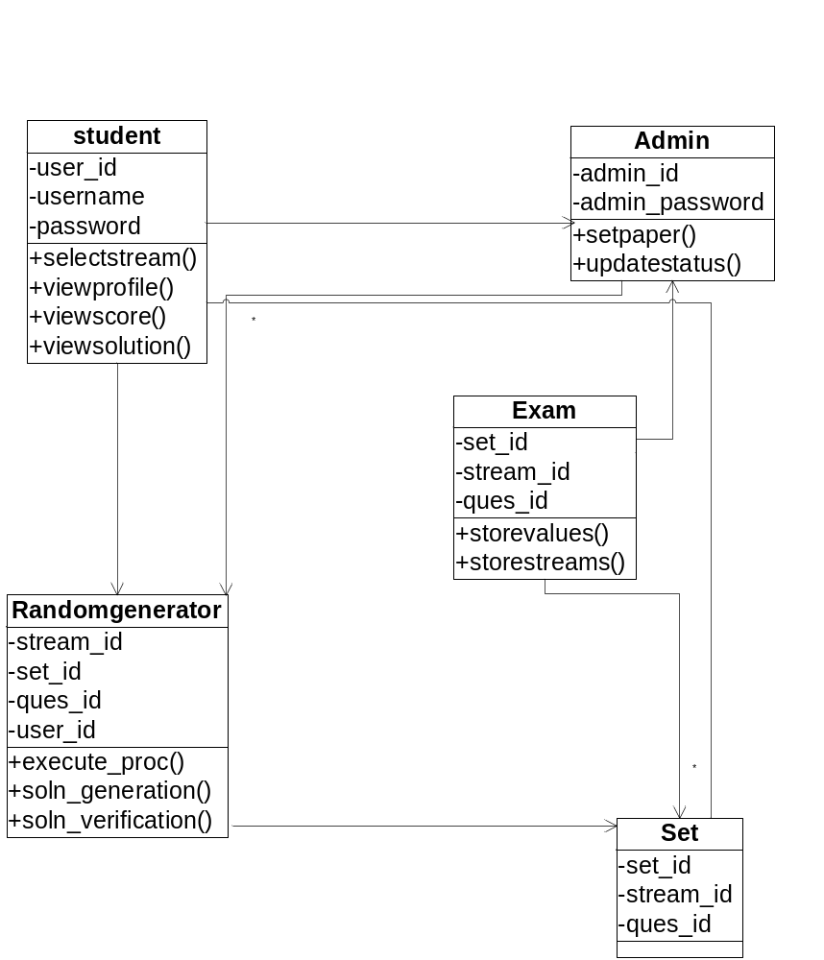

Fig: Class diagram for Online Artificial Intelligence Portal

The description for the Class diagram of Online Artificial Intelligence Portal is given below:

The student class consists of 3 attributes:all 3 of them are required for student verification process.
It has 4 operations:selectstream() lets student select his stream.Rest of 3 methods will allow student display his profile,score and view paper solution respectively.
The admin class has 2 attributes i.e.id and password.
Its function is to set the paper and update the database of student.
Randomno_generator generates the various ids.s
Its operation includes generation of solution and verification of paper.
Exam class consists of 3 attributes used for ids.
The operation of exam class is to stores the values.
Set class consists of 3 ids as its attributes.
Set class has no operations.

PRACTICAL-6
Aim: To study about State Transition Diagram of Online Artificial Intelligence Portal
An STD is a way of describing the time-dependent behavior of a system. The basic consistency rule is: "A system's behavior in any state must be the same no matter by which path the state is arrived at".
States:
- A state is an observable mode of behavior of the system.
- At any time a particular STD can only be in one state.
- .. but a system's behavior could be described by more than one state transition diagram
Transition conditions:
- Internal events or events external to the system
Transition actions:
- Actions in response to the events
- Triggering one-shot actions
- Synchronizing between different STD's
- Producing control outputs
Drawing STD's:
- Identify observable states of the system
- Select the states with normal behavior
- Specify the conditions that mark a transition
- Specify the actions to produce the observable behavior in the destination state for each transition
- If the system is complex, partition the diagram in several STD's.

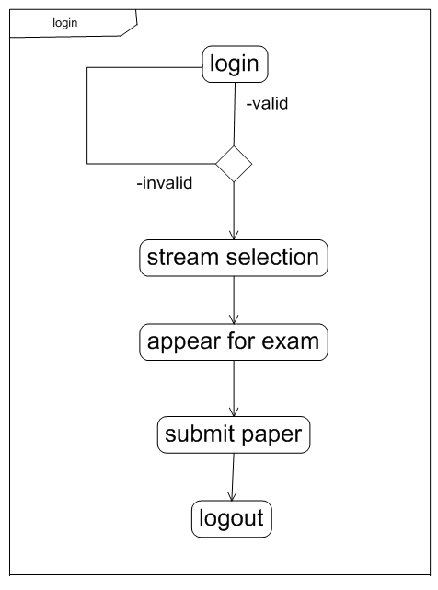

Fig: State Diagram for Login

The description for the State Transition diagram of Online Artificial Intelligence Portal is given below:

The above state diagram shows various states for login process.
Initially, student id and password are verified. If verification is successful then student is allowed to select his stream and thereby appear for exam.
If login fails then student is supposed to login again.
After completion of the paper student submits it and logs out.

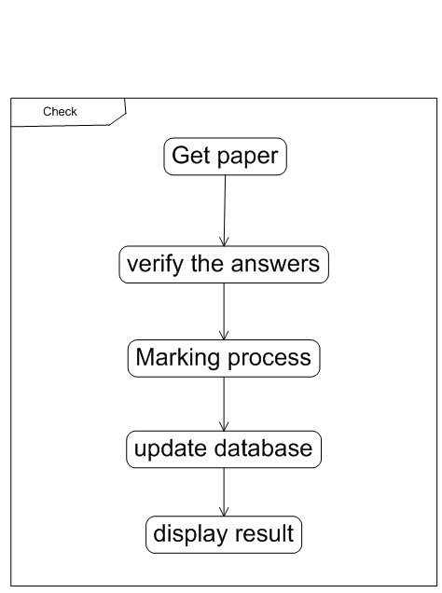

Fig: State Transition diagram for Paper Checking

l

The description for the State Transition diagram of Online Artificial Intelligence Portal is given below:

The above state diagram shows various states for checking process.
The random no. generator gets the paper and starts the verification process.
After the completion of verification, it provides marks to the student.
At the end the database (record) of student is updated with his latest marks.
Result of the student is then displayed.

PRACTICAL-10

Aim: To study about Collaboration diagram of Online Artificial Intelligence Portal

A collaboration diagram describes interactions among objects in terms of sequenced messages. Collaboration diagrams represent a combination of information taken from class, sequence, and use case diagrams describing both the static structure and dynamic behavior of a system.
Basic Collaboration Diagram Symbols and Notations

Class roles
Class roles describe how objects behave. Use the UML object symbol to illustrate class roles, but don't list object attributes.
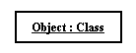

Association roles
Association roles describe how an association will behave given a particular situation. You can draw association roles using simple lines labeled with stereotypes.

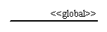

Messages
Unlike sequence diagrams, collaboration diagrams do not have an explicit way to denote time and instead number messages in order of execution. Sequence numbering can become nested using the Dewey decimal system. For example, nested messages under the first message are labeled 1.1, 1.2, 1.3, and so on. The a condition for a message is usually placed in square brackets immediately following the sequence number. Use a * after the sequence number to indicate a loop.

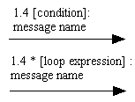

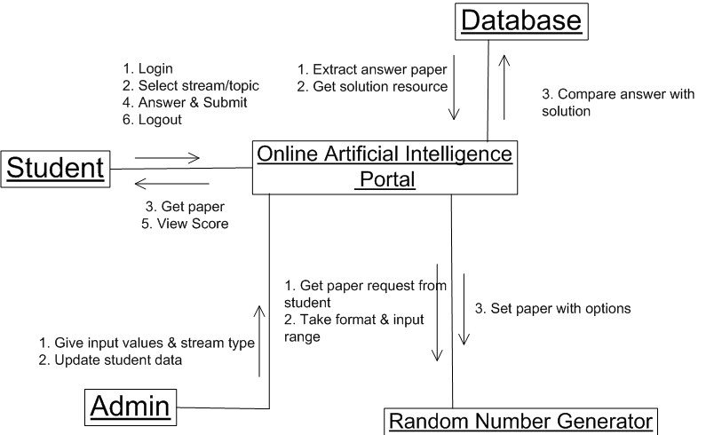

Fig: Collaboration diagram for Online Artificial Intelligence Portal

The description for the Collaboration diagram of Online Artificial Intelligence Portal given below:

The student, the random number generator,admin and database interacts with the online artificial intelligence portal.They interact in different ways.

Student
1. Login
2. Select stream
3. Get paper
4. Answer and submit
5. View scores
Random Number Generator
1. Get paper request from student
2. Take format and input range of exam
3. Set paper with correct options and three nearly wrong options
4. Send paper to student
Administrator
1. Maintain student data
2. Give input values and stream types
3 .Update student score
Database
1. Extract answered paper with student id, exam id
2. Get solution resource with exam id
3. Compare the answers with actual solutions

PRACTICAL-9

Aim: To study about Swimlane diagram of Online Artificial Intelligence Portal

A swimlane (or swim lane) is a visual element used in process flow diagrams, or flowcharts, that visually distinguishes responsibilities for sub-processes of a business process. Swim lanes may be arranged either horizontally or vertically.
The swim lane flowchart differs from other flowcharts in that processes and decisions are grouped visually by placing them in lanes. Parallel lines divide the chart into lanes, with one lane for each person, group or sub-process. Lanes are labeled to show how the chart is organized.
In the accompanying example, the vertical direction represents the sequence of events in the overall process, while the horizontal divisions depict what sub-process is performing that step. Arrows between the lanes represent how information or material is passed between the sub-processes.
Alternately, the flow can be rotated so that the sequence reads horizontally from left to right, with the roles involved being shown at the left edge. This can be easier to read and design, since computer screens are typically wider than they are tall, which gives an improved view of the flow.
Use of standard symbols enables clear linkage to be shown between related flow charts when charting flows with complex relationships.
When used to diagram a business process that involves more than one department, swimlanes often serve to clarify not only the steps and who is responsible for each one, but also how delays, mistakes or cheating are most likely to occur.
Many process modeling methodologies utilize the concept of swimlanes, as a mechanism to organize activities into separate visual categories in order to illustrate different functional capabilities or responsibilities (organizational roles). Swimlanes are used in Business Process Modeling Notation (BPMN) and Unified Modeling Language activity diagram modeling methodologies.

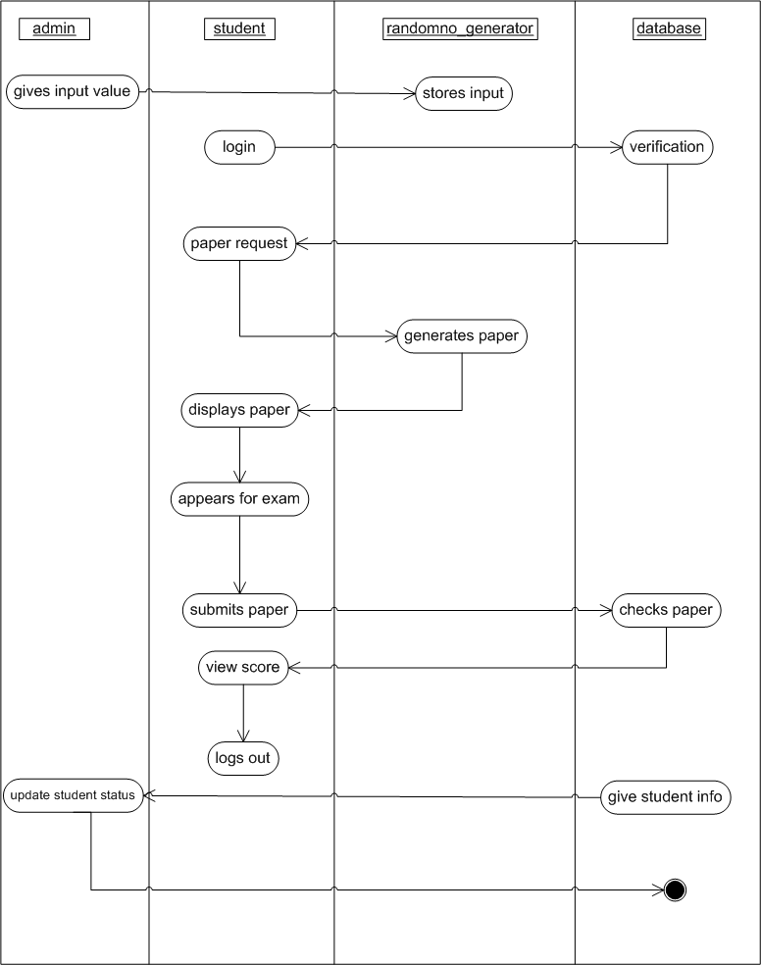

Fig: Swimlane diagram of Online Artificial intelligence Portal

The description for the Swimlane diagram of Online Artificial Intelligence Portal is given below:

The administrator gives input values to the system.The random no. generator stores this input.The student logsin in the system.The database verifies the authenticity of the student.Then, the student sends the paper request.The random no. generator generates the question paper. The student appears for the examination and submits the answer to database.The database verifies the answers with the original solution and send the scores to the student.The student logs out.The administrator gets the student’s information and updates the his/her status.

PRACTICAL-8

Aim: To study about Sequence diagram of Online Artificial Intelligence Portal
A sequence diagram is an interaction diagram that shows how processes operate with one another and in what order. It is a construct of a Message Sequence Chart. A sequence diagram shows object interactions arranged in time sequence. It depicts the objects and classes involved in the scenario and the sequence of messages exchanged between the objects needed to carry out the functionality of the scenario. Sequence diagrams are typically associated with use case realizations in the Logical View of the system under development. Sequence diagrams are sometimes called event diagrams, event scenarios.
A sequence diagram shows, as parallel vertical lines (lifelines), different processes or objects that live simultaneously, and, as horizontal arrows, the messages exchanged between them, in the order in which they occur. This allows the specification of simple runtime scenarios in a graphical manner.

Diagram building blocks: -
If the lifeline is that of an object, it demonstrates a role. Note that leaving the instance name blank can represent anonymous and unnamed instances.
Messages, written with horizontal arrows with the message name written above them, display interaction. Solid arrow heads represent synchronous calls, open arrow heads represent asynchronous messages, and dashed lines represent reply messages. If a caller sends a synchronous message, it must wait until the message is done, such as invoking a subroutine. If a caller sends an asynchronous message, it can continue processing and doesn’t have to wait for a response. Asynchronous calls are present in multithreaded applications and in message-oriented middleware. Activation boxes, or method-call boxes, are opaque rectangles drawn on top of lifelines to represent that processes are being performed in response to the message.
Objects calling methods on themselves use messages and add new activation boxes on top of any others to indicate a further level of processing. When an object is destroyed (removed from memory), an X is drawn on top of the lifeline, and the dashed line ceases to be drawn below it (this is not the case in the first example though). It should be the result of a message, either from the object itself, or another.
A message sent from outside the diagram can be represented by a message originating from a filled-in circle (found message in UML) or from a border of the sequence diagram (gate in UML).

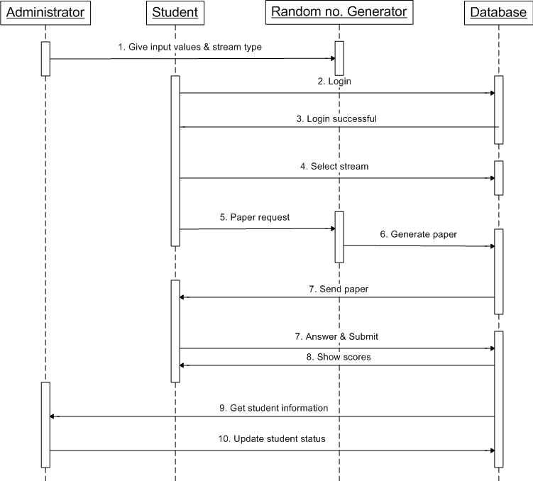

Fig: Sequence diagram for Online Artificial Intelligence Portal

The description for the Sequence diagram of Online Artificial Intelligence Portal is given below:

The above diagram shows the interactions among Administrator, Student, Random no. generator and the Database in sequence.

1. The administrator gives the input values & stream typr to the random mo. Generator.
2. The student Logs in to give exam..
3. The ID and Password of student is verified and acknowledged (i.e. Login successful).
4. After successful login, the student selects the stream/topic of his/her choice.
5. A request to get a question paper is send to the random no. generator.
6. The random no. generator generates the paper and send it to database.
7. The database then sends this paper to the student.
8. The student answers the paper and submit it..
9. The administrator gets the student information
10. The administrator then updates the student information.

